Doubts cast over Pope Francis’ judgement as he, again, backs the wrong man
  - By TOM KINGTON
  - THE TIMES
  - 1:04PM OCTOBER 2, 2020
Doubts about the Pope’s personal judgment have been raised after he fired a top cardinal who oversaw a series of investments made using Vatican money, one of which has allegedly left the Holy See harbouring a substantial loss.
Vatican experts argue that the ousting of Cardinal Becciu, 72, last week is part of a pattern that reveals a character flaw in Pope Francis.
The sacking represented a surprising U-turn for the pontiff after years of supporting Cardinal Becciu. Vatican insiders have pointed out that the firing mirrors other similar episodes. Francis is understood to have put a great deal of trust in close advisers only to then dump them, casting doubt on his own ability to judge their integrity and competence in the first place.
For a pontiff hailed as the people’s pope, Francis is not proving to be a people person, leaving him a lonely figure as the leader of the world’s 1.2 billion Catholics.
Holy See insiders worry that his sense of trust represents a flaw that is putting at risk the Pope’s program to clean up the Vatican’s opaque finances and purge the Church of sex abuse.
“We knew he was impulsive when he was back in Argentina before his election as Pope, but now he risks becoming a medieval monarch,” said Luis Badilla, editor of the news site Il Sismografo.
Ed Condon, an editor at the Catholic News Agency, said Francis had trusted Cardinal Becciu from his first day in office. “Francis inherited Becciu. As the substitute in the secretariat of state he was the Pope’s effective chief of staff, he will have shown Francis the ropes and will have forged a close relationship with him,” he said.
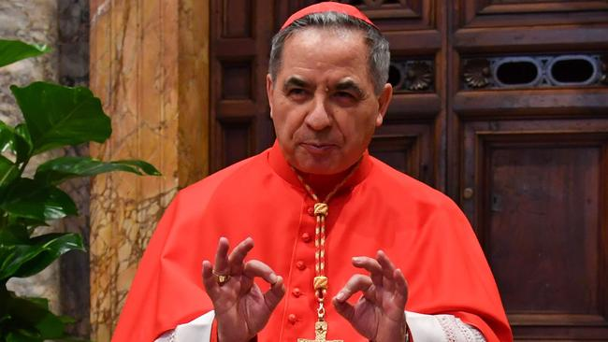

The firing of Cardinal Angelo Becciu, pictured, amid a financial scandal, mirrors other episodes, where Pope Francis has put a great deal of trust in close advisers only to then dump them, casting doubt on his own ability to judge integrity and competence in the first place. Picture: AFP
After his sacking, Robert Mickens, the editor for La Croix International, a religious publication, said: “I was amazed – it looks rash and it seems like the Pope blew his top.” Not only was Cardinal Becciu fired but he was also stripped of his right to vote for the next pope, a punishment usually kept for sex abusers. Questions about the Pope’s faith in the cardinal became more pressing yesterday (Thursday) as reports from the inquiry into the cardinal’s years as deputy at the secretariat of state were leaked. He allegedly authorised the investment of Vatican funds into a former Harrods property in London due to be turned into flats. It was allegedly massively loss-making. The leaked reports were published in Italian newspapers. He also authorised an investment in the Elton John Rocketman biopic which raised eyebrows within the Holy See because of a gay sex scene, and helped one of his brothers receive funds for his beer company.
Cardinal Becciu has said that the Pope has accused him of embezzlement and nepotism, but he claims that the Pope has been misinformed, denies wrongdoing and says he is still ready to lay down his life for the pontiff.
Francis may have had good reason to oust Cardinal Becciu as investigators suspect the cardinal’s advisers worked closely with brokers who invested Vatican funds badly but netted themselves a fortune in fees.
Raffaele Mincione, the consultant who earned millions from the property deal, was hired by the Holy See despite being flagged up by Vatican officials as “morally” unsuited to work for them.
It is not the first time that the Pope has appeared to back the wrong man. Francis took the advice of his old friend, the senior Chilean cardinal Francisco Errazuriz, who downplayed the extent of sex abuse by priests in Chile as a row about the scandal erupted.
It is believed that following Cardinal Errazuriz’s advice, Francis initially dismissed complaints about the Chilean sex abuse as “slanderous”, before finally realising that he was being misled.
Despite Francis’ initial faith in Cardinal Becciu, Ed Condon said the Pope seemed at last to have found the right gear when it comes to cleaning Vatican finances.
“It seems like law enforcement is now being given a free rein,” he said. In a sign that Francis’ transparency drive is taking effect, the Vatican released a detailed balance sheet for the first time, revealing that its net assets in 2019 were about $6.6 billion.

